Article Title
Bayesian hierarchical model of Lake Whitefish cohort strength from sparse trawl data

Author Names
Zachary J. Amidonª, Song S. Qianª, Robin L. DeBruyne^{b}, Mark R. Dufour^{c}, Christine M. Mayerª, Edward. F. Roseman^{b}, Alexis Sakas^{d}

Affiliations
ª University of Toledo Lake Erie Center, Department of Environmental Sciences, 6200, Bayshore Rd., Oregon, OH 43616, USA.
^{b} U.S. Geological Survey, Great Lakes Science Center, 1451 Green Rd., Ann Arbor, MI 48105, USA
^{c} U.S. Geological Survey, Great Lakes Science Center, 380 Huron St., Huron, OH 44839, USA
^{d} The Nature Conservancy, Kitty Todd Preserve, 10420 Old State Line Road, Swanton, OH 43558, USA

Corresponding Author
Zachary Amidon
- Email: zachamidon@gmail.com
- Phone: (607) 262-0672

Keywords
- N-mixture models
- Binomial-Poisson mixture model
- Detection probability
- Sparse count data
- Relative density index

Abstract
Recruitment indices for rare or intermittently recruiting fishes are difficult to estimate from sparse trawl data. We compare two hierarchical mixture models for an annual relative density index (number per ha) of age-0 Lake Whitefish (Coregonus clupeaformis) in Lake Erie using fall bottom-trawl data from New York, Pennsylvania, and Ohio surveys in the central and eastern basins from 1992 to 2021. We evaluate a Binomial-Poisson count mixture and a simplified Bernoulli-Bernoulli binary mixture, each fit as a Bayesian hierarchical mixture model. The hierarchical structure pools information across years to improve precision of annual index estimates, and we assume constant trawl detection for identifiability. In application, both models produced similar indices in low-recruitment years. By retaining information on count magnitudes, the Binomial-Poisson Bayesian hierarchical mixture model better distinguishes moderate from strong recruitment years, whereas the Bernoulli-Bernoulli model tends to reduce the contrast between those years when data are reduced to presence-absence. We quantified model performance using median annual indices, an index classification with poor, fair, and good categories based on the 25th and 75th percentiles across years, and regression of corresponding annual medians. Given the separation between moderate and strong recruitment years and the reduced estimation uncertainty, we recommend the Binomial-Poisson Bayesian hierarchical mixture model for a Lake Whitefish recruitment index derived from trawl data. The Bernoulli-Bernoulli option is computationally faster but less informative when strong cohorts occur, and detecting those conditions is critical for management and for testing hypotheses about recruitment drivers.

1. Introduction
Estimating population size has long been a goal of fishery science (Angelini and Moloney, 2007). For ecologically and economically valuable species, understanding their population dynamics and factors influencing abundance remains central to sustainably managing fish stocks for ecological function, consumers, and industry (Hubert and Quist, 2011). Population estimates are rarely based on complete counts of fish, so they rely on sampling of the population. Sometimes mark recapture techniques can be used to estimate the true population size, although this is usually only possible in closed, smaller water bodies. In larger systems, it is necessary to derive relative abundance indices from available, sometimes limited, data, including catch per unit effort, CPUE (Thompson, 2004). CPUE is considered a relative abundance index, or a relative population measure of a year class or age group (Maunder et al., 2020), and when key assumptions are met it is expected to be proportional to true abundance and to track it in magnitude and direction (Pollock et al., 2002). For example, a twofold increase in relative abundance suggests a twofold increase in the population, and a 20 percent decrease suggests a comparable decline. In this study we followed the same logic and used relative density (fish per ha) as our relative abundance index. We used relative density to summarize population status and trends, and we described the assumptions required for interpreting this index as proportional to true abundance in the sections that follow.

Long-term fisheries-independent trawl surveys are often one of the most useful monitoring data sources to produce relative abundance indices for monitoring programs (Hilborn and Walters, 1992). However, trawl surveys inherently carry biases that can affect the accuracy and representativeness of the data collected, so they are standardized to control for these biases. Standardizing survey methods does not eliminate bias but theoretically holds bias constant so that relative abundance indices can be attributed to relative changes in underlying abundance. If a single standardized survey is used to create a relative abundance index, bias is controlled but the scope of inference based on the index is limited. It is possible to combine multiple standardized surveys to provide a more comprehensive spatial and temporal scope of inference that better represents the target species habitat use (Maunder et al., 2020).

In Lake Erie, annual bottom trawl surveys in the central and eastern basins are conducted by: (1) New York Department of Environmental Conservation, (2) Pennsylvania Fish and Boat Commission, and (3) Ohio Department of Natural Resources (Figure 1; Forage Task Group, 2023; Markham and Wilkins, 2023; Ohio Department of Natural Resources - Division of Wildlife, 2022) to monitor relative abundance of multiple forage and game species. Each state agency uses different trawl-net sizes and protocols (Table 1). However, all surveys have a common goal to collect juvenile fish for assessment purposes. Each trawl samples an estimated lake-floor area; captured fish are then identified and counted. When combining datasets, survey biases such as differences in net selectivity, trawling depth, and seasonal timing are recognized and accepted in exchange for a more ecologically relevant statistical area. These surveys can be used to index the relative abundance of multiple fish species. However, relatively rare species, such as Lake Whitefish (Coregonus clupeaformis), present specific modeling challenges. In addition to their rarity, Lake Erie is the southernmost edge of Lake Whitefish distribution, which necessitates seasonal movement from the cooler and deeper central and eastern basins for summer feeding (Trautman, 1981) to the shallow western basin (Amidon et al., 2021b; Goodyear et al., 1982) to spawn in the fall. Therefore, inclusion of multiple surveys to derive an index could help account for the inherent spatial variability and low detections due to rarity.

There have been multiple approaches developed to categorize variability in data and sources of uncertainty in ecological and fisheries models (Regan et al., 2002; Robinson et al., 2021). Herein, we included sampling and measurement error in our definition of variability, which can be addressed by assigning appropriate probability distributions to the response variables (e.g., the binomial distribution for target species counts). The data-generating process covers the steps from the population of interest to the observed data. Uncertainty arises from model formulation, is unavoidable, and requires careful model construction to accurately represent the data-generating process (Cox et al., 1995). Above water, accurate data collection depends on correct species identification and, when applicable, proper year-class or age group assignment. Misidentification or difficulty discerning species can lead to the exclusion of target species or inclusion of non-target species in the relative abundance index. Underwater, variability arises because target species may actively avoid capture, which leads to imperfect detection, even when the fish are present in the trawl path. Target species that are in low abundance can compound the challenges of trawl-based data analysis. Low abundance can result in the absence of target species in the trawl path, while imperfect detection may lead to missed captures even when species are present. These processes often result in zero-catch observations, which pose difficulties for statistical modeling and interpretation (Cunningham and Lindenmayer, 2005). In this case, the observed catch arises from a two-step process: first, the subset of fish that occupy the trawl path; second, the fraction of those fish that are captured. Because each stage (presence in the path and capture) is subject to uncertainty, the observed data reflect variability at both steps. Thus, the number of fish collected is the outcome of two interrelated random processes: (1) the number of fish present in the trawl path, which can be modeled as a Poisson random variable, and (2) the number of fish captured, given presence (detection probability), which follows a binomial distribution. To address these issues, constructing a Binomial-Poisson mixture model provides a robust framework for capturing the randomness inherent in both fish presence and detection processes, which ultimately improves the utility and interpretability of relative abundance indices (Qian et al., 2022).

Various mixture models to infer population properties have been proposed for studies of other animal species. In recent years with the advent of advanced computation methods such as Markov chain Monte Carlo (MCMC) simulation models, mixing more than one random process (mixture models) has been increasingly used among field biologists because they allow for the reliable estimation of relative abundance from replicated count data of unmarked organisms, which incorporates detection probability and differences in search area between collections (Barker et al., 2018; Denes et al., 2015). However, mixture models are often non-identifiable, which means multiple parameter values produce the same output, which makes it impossible to uniquely estimate the true parameters from the data. Specifically in this case, the detection probability ($p_{d}$) and the number of fish in trawl path (N) cannot be simultaneously quantified, as the number of observed catch (γ) has information of the product of $p_{d}$ and N only (Betancourt 2020). Because the unknown value of N is connected to the population of interest, we needed to specify $p_{d}$ in order to make inferences about the population.

A practical solution to the non-identifiable problem is to fix one of the two parameters based on information independent of the catch data. In our case, the parameter N is linked to the population of interest, but detection probability could be assigned from independent measures of species-specific detection probability or could be fixed at a reasonable value to make the estimated fish density proportional to the true value. However, lacking system and species-specific independent measurements of detection probability, the best option is to standardize collections so that detection probability is relatively consistent between collections, year-class, or age groups, and use a constant detection probability in the model (Gouveia et al., 2023). This results in annual density estimates that are relative rather than absolute, which provides a relative abundance index (Barker et al., 2018).

In situations requiring a constant detection probability to derive a relative abundance index, the simplest model that accurately estimates relative density is often preferred; however, the true density (usually unknown) of the target species influences model structure. High fish densities reduce the number of zero-catch trawls by placing more individuals in the trawl path, whereas low fish densities increase the difficulty of distinguishing true zeros (not present) from false zeros (present but not captured), which leads to an increase in zero observations (Blasco‐Moreno et al., 2019; Maunder and Punt 2004). Because catch data are typically skewed, with few large values (Hansen et al., 2013), they are often reduced to a binary variable (1 = captured, 0 = not captured) under the assumption that binary responses adequately approximate counts when most catches do not exceed one. However, this binary reduction removes information on catch magnitude, even though the occurrence rate still offers insight into population trajectories (Pollock et al. 2002). The degree of information loss depends on how frequently zeros occur, so determining whether to estimate cohort strength using binary or count data should involve assessing the magnitude and direction of that loss (Pollock et al. 2002; Maunder and Punt 2004). While the Binomial-Poisson mixture model uses actual count data and may be computationally intensive, a Bernoulli-Bernoulli mixture model simplifies computation by using binary data but at the expense of some information loss (Maunder and Punt 2004; Hilborn and Walters 1992). However, a model that reduces observed data to a binary response may be inadequate during a higher recruitment year due to an increase in observations greater than one (Maunder and Punt 2004). To address this potential information loss, we compared results from the simplified Bernoulli-Bernoulli mixture model and the full Binomial-Poisson mixture model to determine if the simplified model is adequate for application as an annual relative abundance index. Ultimately, evaluating multiple models can inform the trade-off between complexity, computational time, information retention, and usefulness as an index.

A Bayesian hierarchical mixture model (BHM) structure assumes that annual relative density parameters are exchangeable and connect the annual relative density to the average relative density over the survey period, thereby allowing for information sharing across levels (e.g., years, surveys) that can improve estimation accuracy, particularly when survey catches are low or highly variable. Moreover, the BHM structure accommodates differences in survey design, which is particularly valuable when data are collected by multiple agencies using varying methodologies. Further, the BHM allows for the possibility of updating as additional years of data are gathered (Qian et al., 2022). Using age-0 Lake Whitefish count data from Lake Erie as a case study, we demonstrated how imperfect trawl data can be integrated into a BHM to create a reliable recruitment index. Specifically, our objectives were to:
- formulate a Binomial-Poisson mixture model (count data) and compare it to its simplification of the Bernoulli-Bernoulli (binary detections) mixture model, where both models incorporate the bottom trawl data collection process to estimate an annual relative density and use a constant detection probability.
- use the annual relative density estimates to create analogous recruitment indices between models.
- evaluate whether the Bernoulli-Bernoulli mixture model simplification adequately approximates the Binomial-Poisson mixture model for routine application.
This work illustrated the potential of BHMs to address challenges associated with survey variability and data aggregation, which ultimately provides a more accurate and flexible tool for fisheries assessment and management.

2. Methods
2.1 Data Selection and Field Collection
Lake Whitefish in Lake Erie spawn in the fall, eggs incubate over winter, and larvae hatch in spring. As larvae develop into juveniles during their first growing season, they disperse from western basin spawning and nursery areas into the central and eastern basins and use all or most of Lake Erie to complete early life stages and survive to age-0 (Amidon et al., 2021a; Roseman et al., 2007). By the end of that first growing season, year-class strength is set at fall age-0 (September 13 to December 31; Amidon et al., 2021b). Accordingly, we analyzed only age-0 Lake Whitefish, excluding fish older than age-0 from all models and summaries used to estimate the index. Age-0 Lake Whitefish are demersal and found disproportionately near the lake bottom, so a search area (square) rather than a search volume (cubic) more accurately represents sample effort. Therefore, surveys used in our recruitment index models needed to (1) sample demersal habitat where fall age-0 Lake Whitefish could occur and (2) span enough years to evaluate relative changes in density (index values) over time. Lake Erie bottom trawl surveys matching these criteria included those conducted in the central and eastern basins by New York Department of Environmental Conservation, Pennsylvania Fish and Boat Commission, and Ohio Department of Natural Resources (Figure 1; Forage Task Group 2023; Markham and Wilkins 2023; Ohio Department of Natural Resources – Division of Wildlife 2022) and overlapped from 1992 to 2021.

2.2 Statistical analysis - a mixture model and its simplification
Survey collection protocols varied, using slightly different gear types and vessels, but all tow a bottom trawl on the lake floor targeting small-bodied fishes. The targeted fish species are mobile and may attempt to evade the trawl nets by moving laterally out of the swept area or vertically above the trawl’s head rope. This means that even if a fish initially occupies the sample area swept by the trawl, it may not be captured. Therefore, the number of fish collected is the result of the number of Lake Whitefish initially present in the trawl path and the detection probability of the sampling method, which likely changes with depth and substrate. Each of these three surveys sample over a range of depths and substrate types, however, detection data do not exist for these surveys. To avoid non-identifiable model issues, we assumed detection probabilities were similar between agency trawl surveys, and we assigned a constant detection probability of 31% to all models. This constant detection probability was estimated from juvenile mountain whitefish (Prosopium williamsoni) benthic trawl research in the Kootenai (ID, USA; 48.760961°, -116.389232°) and Green rivers (WY, USA; 41.920627°, -109.862320°; Smith et al., 2015). Analyses are restricted to age-0 fish. Observations of ≥ age-1 fish were not included in the likelihood. Since detection did not vary in our model, the overall scale of λ_{j} was not determined. We interpreted λ_{j} as relative density (an index in number per ha) for comparing years, rather than as an estimate of absolute abundance.
2.3 Binomial-Poisson Mixture Model
The Binomial-Poisson mixture model analyzed observed counts and search area for each sample collected using the method detailed in Section 6.4.5 of Qian et al. (2022). Unlike other modeling methods, such as catch-per-unit-effort, this model described the sampling process and included uncertainty estimates:
- The data-level (1a) represented the observed Lake Whitefish catch count ($γ$_{ij}) of the i^{th} trawl collection in j^{th} year. We assumed counts were binomial random variables with the true (but unknown) number of fish in the trawl path (N_{ij}) and the probability of detecting a fish when it was present in the trawl path ($p_{d}$; 1a).
- The annual level (1b) was a model of the unknown latent variable (N_{ij}), which links the data-level to our parameter of interest (λ_{j}), annual relative density (number per ha). Since the true number of Lake Whitefish in the trawl path is unknown, we modeled N_{ij} as a Poisson random variable, with the expected value being the product of fish density (fish/hectare) in the survey area (λ_{j}) and area (hectare) sampled (A_{ij}; 1b).
- The overall-mean level connected the annual relative density parameters (λ_{j}) by assuming exchangeability (i.e., annual densities are different from each other, but we don’t know how they vary), which took the form of a common prior distribution for all λ_{j} (1c). The log-transformation is the link function (log) for the Poisson parameter.
$$\begin{matrix}γ_{ij} & ∼ & Binom(Pd, N_{ij})\end{matrix} \left(1a\right)$$
$$\begin{matrix}N_{ij} & \sim & Pois(λ_{j}*A_{ij}\end{matrix}) \left(1b\right)$$
$$\begin{matrix}log⁡(λ_{j}) & \sim & N(μ_{λ}, σ_{λ}^{2}\end{matrix}) \left(1c\right)$$
The hierarchical structure (1c) pooled data from multiple years and reduced the overall estimation uncertainty in λ_{j}.

2.4 Bernoulli-Bernoulli Mixture Model (computational shortcut)
Because Lake Whitefish is relatively rare species in Lake Erie, observed catch numbers (Table 2) are mostly zeros with occasional small positive counts. In similar situations, a common practice of simplifying computation is to reduce the count data to binary: 0’s for absent and 1’s for present. Accordingly, we simplified our model (1a-c) to a Bernoulli-Bernoulli mixture model. The probability of a positive observation is the product of the detection probability and the probability that at least one Lake Whitefish was present in the sample:
$$\begin{matrix}γ_{ij} & ∼ & Bern(θ_{ij})\end{matrix} \left(2a\right)$$
$$θ_{ij}= P_{ij}*pd \left(2b\right)$$
where γ_{ij} is the observed presence-absence (0 = absent and 1 = present), θ is the probability of observing a positive result (e.g., γ_{ij} = 1), P_{ij} is the probability that at least one Lake Whitefish was present in the i^{th} trawl collection in j^{th} year, and the probability that at least one Lake Whitefish was present in the trawling area (A):

$$P_{ij}= 1-e^{{-λ}_{j}*A_{ij}} \left(2c\right)$$
The same hierarchical structure (1c) was used to connect data from multiple years.
The Binomial-Poisson mixture model reduces to the Bernoulli-Bernoulli simplification when we assume $N_{ij}=1$ and collapse counts to presence-absence. If $N_{ij}>1$, the probability of a positive observation is $θ_{ij}=1-(1-p_{d})^{N_{ij}}$, which equals $p_{d}$only when $N_{ij}=1$ and is otherwise larger than $p_{d}$. Consequently, the Bernoulli-Bernoulli simplification effectively inflates detection when multiple fish are available and it underestimates $γ_{j}$ relative to the Binomial-Poisson mixture model. The effectiveness of the Bernoulli-Bernoulli simplification is, therefore, case specific and depends on how close the probability of exactly one fish being present is to the probability of at least one fish being present, and on how close the probability of detecting one fish is to the probability of detecting at least one fish. We ran both models and compared their annual indices. The simplified model is ineffective when the difference between the two model results is substantial.

The models were fit using Markov Chain Monte Carlo sampling through the R interface to Stan software (Qian et al., 2022; Stan Development Team 2023). Inference was based on 50,000 iterations with eight parallel chains including a burn-in of 25,000 iterations, then keeping 1 of every 80 iterations, which resulted in 2,500 samples. We assessed the convergence of the model by evaluating the effective sample size (ESS) and Gelman-Rubin criterion $\hat{R}$ ≈ 1.00 (Gelman and Rubin 1992). All statistical analyses were performed in the R statistical environment (R Core Team 2023).

2.5 Index values and comparison
Since detection probability was assumed to be constant, annual density estimates ($λ_{j}$) were relative to each other, so that higher values indicated more successful recruitment years. Therefore, the annual relative density estimate ($λ_{j}$) from the Binomial-Poisson and Bernoulli-Bernoulli mixture models can be used as a relative annual index of Lake Whitefish cohort strength. Two commonly used indices were calculated from each model output for use in the model output comparison: (1) median annual value (median number per hectare) and (2) a categorical index value created using median annual values by assigning years above the 75th percentile to high recruitment years (good), years below the 25th percentile to low recruitment years (poor), and the middle 50th percentile to medium recruitment years (fair).

Median annual index values for each model were compared using linear regressions for corresponding years. The slope and correlation coefficient (r) values were reported with a slope and r of 1 indicating a perfect match between model index variables. Categorical index values were evaluated based on the percent similarity between the Binomial-Poisson and the Bernoulli-Bernoulli mixture model indices.

3. Results
State agency datasets overlap for 1992-2021 (data were not collected in Pennsylvania during 2006, 2010, 2011, 2014, and 2021), which provides 30 years of data (Table 2). The analytical dataset included only tows with a reliable age-0 determination; observations of ≥ age-1 fish were not analyzed. Tows with ≥ age-1 but no age-0 were retained as zero age-0 observations. The Binomial-Poisson mixture model took 74 hours to complete the computation, and the Bernoulli-Bernoulli mixture model took 65 minutes to complete, which resulted in a 98.5% reduction in computation time relative to the Binomial-Poisson mixture model. Both models converged well as shown in Table 2, with all $\hat{R}$ values ≈ 1.00 and large effective sample sizes, indicating well-mixed chains.

Both median model predictions suggested variable recruitment of Lake Whitefish from 1992 to 2005, with the largest recruitment years in the series being 1996 and 2003 (Figure 2). Both models estimated almost no recruitment from 2006 to 2014. From 2015 to 2021 both models suggested some recruitment in half the years.

Median annual index values from the Binomial-Poisson mixture model were higher than those for the Bernoulli-Bernoulli mixture model (slope = 0.88, r = 0.98) with greater deviation and higher uncertainty at higher values (Figure 2; Figure 3). Binomial-Poisson and Bernoulli-Bernoulli mixture model categorical index values were 86.7% similar (Table 2).

4. Discussion
Fisheries trawl datasets with many zero-catch data points such as that from Lake Erie Lake Whitefish are common and difficult to analyze. It is often assumed that these data contain little useful information and observed catch numbers are often reduced to presence (1) or absence (0) as in the Bernoulli-Bernoulli mixture model. A comparison of Binomial-Poisson and Bernoulli-Bernoulli mixture model median relative density (abundance index; fish per ha) values showed that the two models predicted similarly during low recruitment years but deviated during higher recruitment years (Figure 3). Although Lake Whitefish recruitment in Lake Erie is usually very low, high recruitment occasionally occurs, and it’s critical that high recruitment years are accurately estimated in the index to understand recruitment drivers. Since the Bernoulli-Bernoulli mixture model estimates were consistently lower (with higher uncertainty) than the Binomial-Poisson mixture model estimates at high recruitment, the Binomial-Poisson mixture model is the appropriate model to use for a Lake Whitefish recruitment index in Lake Erie.
To avoid the non-identifiability issue in the Lake Whitefish models, a constant $p_{d}$ was used, which provides a relative density for the statistical area (Smith et al., 2015). To move from a relative index to an absolute population estimate for this study area, a separate study to estimate detection probability would be required (Barker et al., 2018). Light availability and turbidity can inhibit visual identification of fishes at depth, which makes it difficult to estimate a unique $p_{d}$ for trawl surveys. However, a split-beam sonar system mounted on a tow body, which allows sampling of the water column directly in front of the trawl net, may allow for a $p_{d}$ estimate of fall age-0 sized Lake Whitefish (Hoffman et al., 2009), and provide a population estimate for the statistical area. A population estimate for the entire lake (beyond our study area) would require more knowledge on the spatial distribution of age-0 Lake Whitefish to extrapolate our statistical area estimate across the lake (Thompson, 2004).
Lake Whitefish live in a three-dimensional aquatic environment and are not uniformly distributed. To calculate an absolute population estimate for the entire lake, information on how Lake Whitefish are distributed in their environment would be required. For example, water temperature seasonally restricts lateral movement to the western basin and some nearshore locations, which results in density concentrations around available habitat prey resources, or depth. In principle, one could account for fish distribution at different depths by modeling density as λ_{ijk} (e.g. i^{th} trawl, in j^{th} year, at k^{th} depth) and, when relevant environmental variables are available, include them in an extension of equation (1c). However, the sparse data in the latter part of the time series provided inadequate information for adopting a covariate modeling approach. Instead, we view the current Binomial-Poisson and Bernoulli-Bernoulli Bayesian hierarchical mixture models primarily as tools for deriving a robust recruitment index from trawl data. With substantially more positive detections or targeted studies to estimate detection and habitat use, similar model structures could be revisited to explore covariate effects or lake-wide abundance.
We found the preferred method to create a relative abundance index for a sparsely distributed unmarked species is the Binomial-Poisson mixture model since it provides a more robust estimate than the Bernoulli-Bernoulli mixture model. But its computation takes considerably longer, largely due to the integration of N, which requires a summation from zero to infinity. One way to overcome long computation is by sequentially updating the model when new data are available, rather than running the entire model each time an update is required (Efron, 1996; Qian et al., 2022). In our Lake Whitefish example, if time can be allocated to initially run the model (1992-2021), we can use the posterior hyper-distribution $μ_{λ}, σ_{λ}^{2}$ (1c) to serve as the prior distribution for λ_{j} and to estimate the future index annually (e.g., 2022 only). Since future model runs will only include one year’s worth of data, computation time will be reduced and all model parameters (including $μ_{λ}, σ_{λ}^{2}$ ) will be updated. The reduced computations and associated model run time can allow for more precise relative abundance indices to be used without overburdening decision makers, which improves model transparency.
Abundance information is critical for understanding population dynamics and drivers. However, imperfect detection and other phenomena that cause high numbers of zero-catch data can obscure ecological patterns (Denes et al., 2015). For species with a small population or low-abundance, it can be argued that estimation of a detection probability is not feasible or adds little value to index data as long as detection probability is stable, which stresses the importance of a uniform sampling method (Thompson, 2004). Indices are often not utilized as credible sources of information for management decisions because critics can easily construct scenarios in which the index assumption of consistent detection probability is not valid (Thompson, 2004). However, by providing a model structure and discussing biases, interpretation, and application from a fisheries context, we provided a framework to estimate relative density and sought to improve certainty in fisheries stock assessment and management decisions. With a model that explicitly incorporates the data-generating process and associated uncertainty, we can modify, expand, and improve the model when new information is available, thereby making incremental progress possible.
5. Acknowledgements
This work was supported by the Great Lakes Restoration Initiative, The Nature Conservancy, and the Margaret L. Wendt Foundation. The authors acknowledge the contributions New York State Department of Environmental Conservation, Ohio Department of Natural Resources, and the Pennsylvania Fish and Boat Commission for collecting and processing the long-term trawl data used in this analysis.
6. Figure Captions and Tables
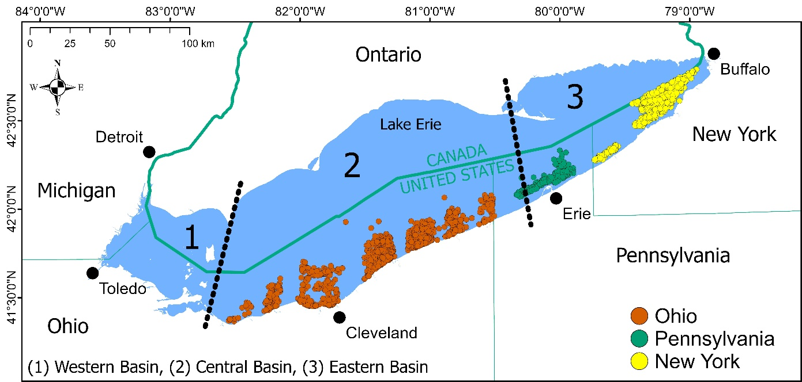
Figure 1. Map of Lake Erie showing fall bottom-trawl sampling sites by collection agency. Symbols indicate trawl locations from the New York State Department of Environmental Conservation, Pennsylvania Fish and Boat Commission, and Ohio Department of Natural Resources. U.S. states and the Canadian province bordering Lake Erie and major lakeshore cities are labeled for geographic reference. The western (1), central (2), and eastern (3) basins of Lake Erie are delineated by black dashed lines.

Table 1. Collection agencies, net characteristics, collection protocols, and typical fall sampling periods for state bottom trawl surveys used to collect age-0 Lake Whitefish in the central and eastern basins of Lake Erie. Net dimensions with an asterisk (*) were measured using trawl mensuration gear, and those with a double asterisk (**) were measured without mensuration gear.
Collection agency | Net characteristics | Collection protocols | Typical fall sample dates
Ohio Department of Natural Resources, Division of Wildlife | Yankee two-seam bottom trawl; 10.4 m head rope; 25.0 mm bar cod-end mesh with 13 mm stretch liner; wing spread approximately 5.9 to 4.2 m*; net gape 1.5 to 1.7 m* | Depth-stratified bottom trawls conducted in 5 to 20 m; five-minute bottom tows at depths less than 10 m and ten-minute bottom tows at depths greater than or equal to 10 m | Fall survey conducted after September 13, typically mid-September through November
Pennsylvania Fish and Boat Commission | Single seam bottom trawl; 10.1 m head rope; 6.4 mm bar cod-end mesh; panel mesh unknown; wing spread 5.44 m**; net gape 1.22 m** | Depth-stratified bottom trawls conducted in 5 to 60 m; ten-minute bottom tows at all depths | Fall sampling generally after September 13 through December
New York State Department of Environmental Conservation, Lake Erie Unit | Four seam bottom trawl; 8.0 m head rope; 10.2 mm stretch cod-end mesh; 50.8 mm stretch panel mesh; wing spread 4.21 m*; net gape 1.12 m* | Bottom trawls conducted on trawlable substrate between approximately 15 and 30 m depth; standard tow duration ten minutes | Fall trawling conducted in October and November

Table 2. Yearly recruitment index outputs for age-0 Lake Whitefish (Coregonus clupeaformis) from the Binomial-Poisson (B-P) and Bernoulli-Bernoulli (B-B) Bayesian hierarchical mixture models, expressed as relative density (abundance index; number per ha). Year refers to the cohort year, defined as the calendar year in which fish were indexed as age-0 during fall bottom trawl surveys. For each cohort, the table lists the posterior median relative density for each model and the categorical index class (good, fair, or poor) based on median values partitioned at the 75th and 25th percentiles across years. Convergence diagnostics are reported as B-P/B-B $\hat{R}$ and ESS (effective sample size). The rightmost columns summarize the trawl inputs used in modeling, including the total number of fall trawls analyzed (Total trawls), mean swept area per tow in hectares (Mean ha) with standard deviation (SD), number of tows with at least one age-0 Lake Whitefish captured (Pos. tows), and the total number of age-0 Lake Whitefish counted (Age-0 count). Only age-0 fish were analyzed when constructing the recruitment index. Survey coverage varied by year, and Pennsylvania data were unavailable for 2006, 2010, 2011, 2014, and 2021.
 | Binomial-Poisson |  |  |  | Bernoulli-Bernoulli
Year | Median | Index | B-P  $$\hat{R}$$ | B-P ESS | Median | Index | B-B  $\hat{R}$ | B-B ESS | Total trawls | Mean ha (SD) | Pos. tows | Age-0 count
1992 | 0.80 | Fair | 1 | 2404 | 0.74 | Fair | 1 | 2453 | 89 | 0.42 (0.12) | 8 | 10
1993 | 2.13 | Good | 1 | 2840 | 2.25 | Good | 1 | 2194 | 72 | 0.38 (0.15) | 14 | 19
1994 | 2.71 | Good | 1 | 2431 | 2.06 | Good | 1 | 2543 | 79 | 0.43 (0.11) | 15 | 29
1995 | 0.89 | Fair | 1 | 2638 | 0.57 | Fair | 1 | 2699 | 91 | 0.46 (0.13) | 7 | 12
1996 | 3.39 | Good | 1 | 2777 | 3.27 | Good | 1 | 2648 | 115 | 0.46 (0.10) | 28 | 56
1997 | 0.02 | Poor | 1 | 2568 | 0.02 | Poor | 1 | 2524 | 108 | 0.42 (0.12) | 0 | 0
1998 | 0.12 | Fair | 1 | 2417 | 0.12 | Fair | 1 | 2555 | 111 | 0.44 (0.14) | 2 | 2
1999 | 0.22 | Fair | 1 | 2413 | 0.23 | Fair | 1 | 2780 | 122 | 0.43 (0.16) | 4 | 4
2000 | 0.02 | Poor | 1 | 2214 | 0.02 | Poor | 1 | 2231 | 127 | 0.38 (0.09) | 0 | 0
2001 | 2.07 | Good | 1 | 2401 | 0.62 | Fair | 1 | 2589 | 88 | 0.38 (0.08) | 6 | 22
2002 | 0.02 | Poor | 1 | 2557 | 0.02 | Poor | 1 | 2304 | 114 | 0.38 (0.09) | 0 | 0
2003 | 9.74 | Good | 1 | 2587 | 8.74 | Good | 1 | 2337 | 113 | 0.38 (0.09) | 38 | 130
2004 | 1.61 | Good | 1 | 2223 | 0.34 | Fair | 1 | 2682 | 96 | 0.38 (0.10) | 4 | 19
2005 | 1.30 | Good | 1 | 2559 | 0.95 | Good | 1 | 2410 | 102 | 0.37 (0.10) | 10 | 16
2006 | 0.08 | Fair | 1 | 2490 | 0.09 | Fair | 1 | 2257 | 92 | 0.37 (0.09) | 1 | 1
2007 | 0.07 | Fair | 1 | 2337 | 0.08 | Fair | 1 | 2509 | 103 | 0.37 (0.08) | 1 | 1
2008 | 0.02 | Poor | 1 | 2587 | 0.02 | Poor | 1 | 2405 | 96 | 0.38 (0.14) | 0 | 0
2009 | 0.02 | Poor | 1 | 2468 | 0.02 | Poor | 1 | 2455 | 99 | 0.40 (0.14) | 0 | 0
2010 | 0.03 | Fair | 1 | 2407 | 0.03 | Fair | 1 | 2569 | 52 | 0.37 (0.07) | 0 | 0
2011 | 0.02 | Fair | 1 | 2499 | 0.02 | Fair | 1 | 2506 | 87 | 0.37 (0.09) | 0 | 0
2012 | 0.02 | Poor | 1 | 2544 | 0.02 | Poor | 1 | 2589 | 118 | 0.38 (0.10) | 0 | 0
2013 | 0.02 | Poor | 1 | 2204 | 0.02 | Poor | 1 | 2033 | 99 | 0.38 (0.11) | 0 | 0
2014 | 0.14 | Fair | 1 | 2655 | 0.14 | Fair | 1 | 2415 | 53 | 0.35 (0.07) | 1 | 1
2015 | 1.70 | Good | 1 | 2569 | 1.21 | Good | 1 | 2538 | 89 | 0.39 (0.10) | 11 | 19
2016 | 0.02 | Poor | 1 | 2480 | 0.02 | Poor | 1 | 2378 | 134 | 0.38 (0.10) | 0 | 0
2017 | 0.15 | Fair | 1 | 2276 | 0.15 | Fair | 1 | 2523 | 101 | 0.38 (0.09) | 2 | 2
2018 | 1.20 | Fair | 1 | 2550 | 1.15 | Good | 1 | 2668 | 63 | 0.36 (0.07) | 7 | 9
2019 | 0.91 | Fair | 1 | 2532 | 0.92 | Good | 1 | 2482 | 105 | 0.38 (0.07) | 10 | 12
2020 | 0.16 | Fair | 1 | 2503 | 0.16 | Fair | 1 | 2261 | 95 | 0.38 (0.08) | 2 | 2
2021 | 0.23 | Fair | 1 | 2599 | 0.23 | Fair | 1 | 2411 | 66 | 0.37 (0.08) | 2 | 2

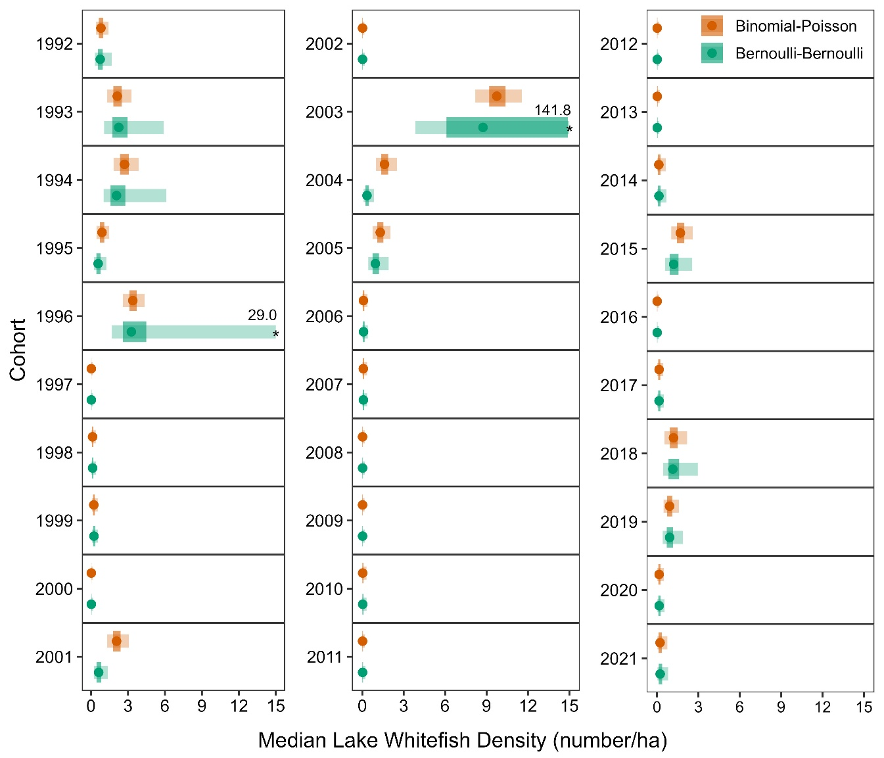
Figure 2. Annual relative density of age-0 Lake Whitefish by cohort estimated with Binomial-Poisson and Bernoulli-Bernoulli mixture models. The x-axis is Lake Whitefish density (number per ha). Points are posterior medians; shaded bands are the 50% (dark) and 95% (light) credible intervals. Cohort (y-axis) denotes the calendar year in which fish were indexed at age-0 during the fall survey (i.e., their hatch year). Pennsylvania data were unavailable for 2006, 2010, 2011, 2014, and 2021. The 95% credible intervals for 1996 and 2003 extend beyond the plotted range; values are indicated by an asterisk. Older age classes were not used to construct the age-0 index; see Methods for details on age-class handling and detection assumptions.
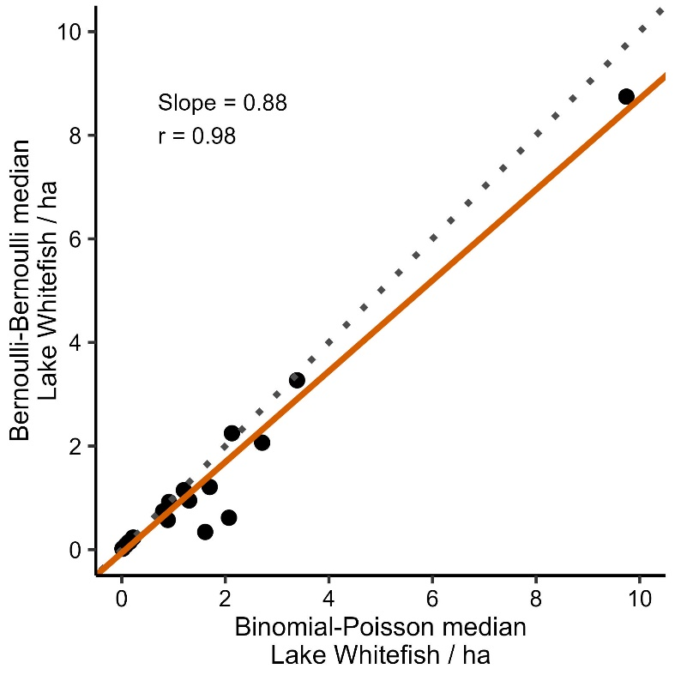
Figure 3. Relationship between annual median recruitment indices for age-0 Lake Whitefish from the Binomial-Poisson and Bernoulli-Bernoulli Bayesian hierarchical mixture models. Each point represents a cohort-year median index (number per ha). The solid orange line is the fitted linear regression of Bernoulli-Bernoulli medians on Binomial-Poisson medians, with slope and correlation coefficient (r) reported on the panel. The dotted gray line is the 1:1 line for reference, so departures from this line indicate differences between the two model-based indices.

7. References
Amidon, Z., DeBruyne, R., Roseman, E.F., Mayer, C.M., 2021a. Spatial extent of contemporary Lake Whitefish spawning in western Lake Erie. Adv. Limnol. 66:163-172.
Amidon, Z.J., DeBruyne, R.L., Roseman, E.F., Mayer, C.M., 2021b. Contemporary and historic dynamics of lake whitefish (Coregonus clupeaformis) eggs, larvae, and juveniles suggest recruitment bottleneck during first growing season. Ann. Zool. Fenn. 58:161-175.
Angelini, R., Moloney, C.L., 2007. Fisheries, ecology and modelling: an historical perspective. Panam. J. Aquat. Sci. 2:75-85.
Barker, R.J., Schofield, M.R., Link, W.A., Sauer, J.R., 2018. On the reliability of N‐mixture models for count data. Biometrics. 74:369-377.
Betancourt, M., 2020. Identity crisis. https://betanalpha.github.io/assets/case_studies/identifiability.html. Accessed 15 April 2025.
Blasco‐Moreno, A., Pérez‐Casany, M., Puig, P., Morante, M., Castells, E., 2019. What does a zero mean? Understanding false, random and structural zeros in ecology. Methods Ecol. Evol. 10:949-959.
Cox, D.R., Bayarri, M., Cuadras, C., Bernardo, J.M., Girón, F., Moreno, E., Keiding, N., Lindley, D., Pericchi, L., 1995. The relation between theory and application in statistics. Test. 4:207-261.
Cunningham, R.B., Lindenmayer, D.B., 2005. Modeling count data of rare species: some statistical issues. Ecology. 86:1135-1142.
Denes, F.V., Silveira, L.F., Beissinger, S.R., 2015. Estimating abundance of unmarked animal populations: accounting for imperfect detection and other sources of zero inflation. Methods Ecol. Evol. 6:543-556.
Efron, B., 1996. Empirical Bayes methods for combining likelihoods. J. Am. Stat. Assoc. 91:538-550.
Forage Task Group, 2023. Report of the Lake Erie Forage Task Group, March 2023. Ann Arbor, Michigan, USA: Presented to the Standing Technical Committee, Lake Erie Committee of the Great Lakes Fishery Commission.
Gelman, A., Rubin, D.B., 1992. Inference from iterative simulation using multiple sequences. Stat. Sci. 7:457-472.
Goodyear, C., Edsall, T., Dempsey, D.O., Moss, G., Polanski, P., 1982. Atlas of the spawning and nursery areas of Great Lakes fishes. Washington, DC: U.S. Fish and Wildlife Service.
Gouveia, A., Qian, S., Mayer, C., Smith, J., Bossenbroek, J., Hintz, W.D., Mapes, R., Weimer, E., Navarro, J., Dettmers, J.M., 2023. A restructured Bayesian approach to estimate the abundance of a rare and invasive fish. Biol. Invasions. 25:1711-1721.
Hansen, G.J., Vander Zanden, M.J., Blum, M.J., Clayton, M.K., Hain, E.F., Hauxwell, J., Izzo, M., Kornis, M.S., McIntyre, P.B., Mikulyuk, A., 2013. Commonly rare and rarely common: comparing population abundance of invasive and native aquatic species. PLoS One. 8:e77415.
Hilborn, R., Walters, C.J., 1992. Quantitative Fisheries Stock Assessment: Choice, Dynamics and Uncertainty. Springer.
Hoffman, J.C., Bonzek, C.F., Latour, R.J., 2009. Estimation of bottom trawl catch efficiency for two demersal fishes, the Atlantic croaker and white perch, in Chesapeake Bay. Mar. Coast. Fish. 1:255-269.
Hubert, W.A., Quist, M.C., 2011. Inland Fisheries Management in North America, 3rd ed. American Fisheries Society, Bethesda, MD.
Markham, J.L., Wilkins, P.D., 2023. Forage and juvenile yellow perch survey. Section C in NYSDEC 2023, Lake Erie Fisheries Research Unit 2022 Annual Report. Albany: New York State Department of Environmental Conservation.
Maunder, M.N., Punt, A.E., 2004. Standardizing catch and effort data: a review of recent approaches. Fish. Res. 70:141-159.
Maunder, M.N., Thorson, J.T., Xu, H., Oliveros-Ramos, R., Hoyle, S.D., Tremblay-Boyer, L., Lee, H.H., Kai, M., Chang, S.-K., Kitakado, T., 2020. The need for spatio-temporal modeling to determine catch-per-unit effort based indices of abundance and associated composition data for inclusion in stock assessment models. Fish. Res. 229.
Ohio Department of Natural Resources - Division of Wildlife, 2023. Ohio’s Lake Erie Fisheries, 2022. Annual status report Federal Aid in Fish Restoration Project F-69-P. Ohio Department of Natural Resources, Division of Wildlife, Lake Erie Fisheries Units, Fairport and Sandusky.
Pollock, K.H., Nichols, J.D., Simons, T.R., Farnsworth, G.L., Bailey, L.L., Sauer, J.R., 2002. Large scale wildlife monitoring studies: statistical methods for design and analysis. Environmetrics. 13:105-119.
Qian, S.S., DuFour, M.R., & Alameddine, I., 2022. Bayesian Applications in Environmental and Ecological Studies with R and Stan, first ed. Chapman and Hall/CRC.
R Core Team, 2023. A language and environment for statistical computing. Vienna, Austria: R Foundation for Statistical Computing.
Regan, H.M., Colyvan, M., Burgman, M.A., 2002. A taxonomy and treatment of uncertainty for ecology and conservation biology. Ecol. Appl. 12:618-628.
Robinson, K.F., Alsip, P.J., Drake, A.R., Kao, Y.-C., Koops, M.A., Mason, D.M., Rutherford, E.S., Zhang, H., 2021. Reviewing uncertainty in bioenergetics and food web models to project invasion impacts: Four major Chinese carps in the Great Lakes. J. Great Lakes Res. 47:83-95.
Roseman, E.F., Kennedy, G.W., Boase, J., Manny, B.A., Todd, T.N., Stott, W., 2007. Evidence of Lake Whitefish Spawning in the Detroit River: Implications for Habitat and Population Recovery. J. Great Lakes Res. 33:397-406.
Smith, C.D., Quist, M.C., Hardy, R.S., 2015. Detection probabilities of electrofishing, hoop nets, and benthic trawls for fishes in two western North American rivers. J. Fish Wildl. Manag. 6:371-391.
Stan Development Team, 2023. RStan: the R interface to Stan. R package version 2.21.8 [software]. https://mc-stan.org.
Thompson, W., 2004. Sampling rare or elusive species: concepts, designs, and techniques for estimating population parameters: Island Press.
Trautman, M.B., 1981. The Fishes of Ohio, 2nd ed. Ohio State University Press, Columbus, OH.

